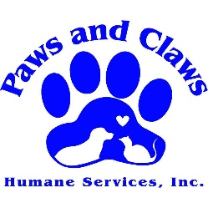
Paws and Claws Humane Services, Inc.
P.O. Box 265
Irwinton, Ga 31042

Spay & Neuter Form
(Please print)

Name (Owner): ________________________________________________________________________________
Address: ____________________________________________ City: ___________________________ State: ____
Email: ________________________________________________________________________________________
Phone #: ______________________________________________________________________________________

DOG or CAT: ___________________________ Breed: _________________________________________________
Pet’s Name: _____________________________________________________ Age: _________________________
Color: ________________________________________ Weight: ____________________ Shots: _______________
Please provide shot records if available.
Which Vet do you prefer?
- Gordon Animal Clinic
- Sandersville Veterinary Clinic
- Animal Medical Clinic of Laurens County
NO BOARDING TO BE PAID BY PAWS AND CLAWS HUMANE SERVICES
_____________________________________________________________________________________________
*****PAWS AND CLAWS HUMANE SERVICES, INC. USE ONLY*****

Voucher #: _____________________ Date Issued: ____________________ Appointment Date: _______________
Payment Amount: ______________________________________________________________________________
Board Member Approval: ________________________________________________________________________

